31.60: We want Maximum power implies
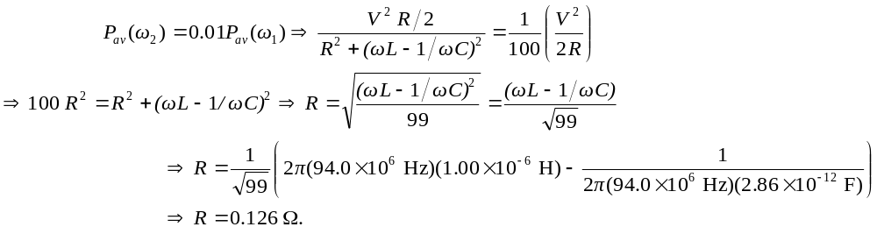
This answer is very sensitive to the capacitance so you may have to carry the first part of the problem out to more significant figures.

